H.T No
Regulations:
A20

Sreenidhi Institute of Science and Technology
(An Autonomous Institution)
Code No:8D715 Date: 15-June-2024 (FN)

B.Tech IV-Year I- Semester External Examination, June - 2024 (Supplementary)
PRINCIPLES AND TECHNIQUES OF ARTIFICIAL INTELLIGENCE(ECM)

Time: 3 Hours Max.Marks:70

Note: a) No additional answer sheets will be provided.
b) All sub-parts of a question must be answered at one place only, otherwise it will not be valued.
c) Missing data can be assumed suitably.

Bloom's Cognitive Levels of Learning (BCLL)

Remember | L1 | Apply | L3 | Evaluate | L5
Understand | L2 | Analyze | L4 | Create | L6

Part - A Max.Marks:20
Answer all QUESTIONS

 |  | BCLL | CO(s) | Marks
1 | What is philosophy of Artificial Intelligence (AI)? | L1 | CO1 | [2M]
2 | Define fitness number in A* Search Algorithm? | L2 | CO2 | [2M]
3 | Explain the various Quantifiers in predicate logic. | L3 | CO3 | [2M]
4 | What is maximum expected utility (MEU) in decision theory. | L3 | CO4 | [2M]
5 | Give advantages of soft computing. | L1 | CO5 | [2M]
6 | Give various components of Expert Systems | L3 | CO6 | [2M]
7 | Explain structure of Artificial Intelligent with suitable example. | L2 | CO1 | [2M]
8 | What is maximum expected utility (MEU) in decision theory. | L3 | CO3 | [2M]
9 | Give drawbacks of using logic based approach for uncertain reasoning. | L1 | CO5 | [2M]
10 | Write first order logic for following statement:  Some girls play music. | L2 | CO6 | [2M]
Part – B Max.Marks:50
ANSWER ANY FIVE QUESTIONS. EACH QUESTION CARRIES 10 MARKS.

 |  |  | BCLL | CO(s) | Marks
11. | a) | What is PEAS representation? Give PEAS analysis for designing automatic cars. | L6 | CO1 | [5M]
 | b) | What are main components of Learning agent? Explain with block diagram. | L4 | CO1 | [5M]
12. | a) | Use the Alpha-Beta pruning algorithm to prune the game tree given below, assuming child nodes are visited from left to right. Show all final alpha and beta values computed at root, each internal node explored, and at the top of pruned branches.  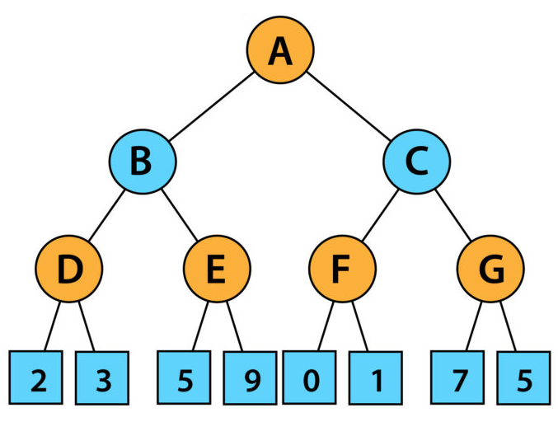 | L5 | CO2 | [5M]
 | b) | Explain about greedy best first search? | L5 | CO2 | [5M]
13. | a) | Explain the various Quantifiers in predicate logic. | L5 | CO3 | [5M]
 | b) | What are inference rules for Propositional Logic? | L4 | CO3 | [5M]
14. | a) | Compare and Contrast Policy Iteration and Value Iteration. | L5 | CO4 | [5M]
 | b) | Write about Partially Observable Markov Decision Process. | L6 | CO4 | [5M]
15. | a) | Discuss in detail Artificial Neural Network? How it is categorized as soft computing method. | L3 | CO5 | [5M]
 | b) | Differentiate between Supervised and Unsupervised machine learning methods. | L5 | CO5 | [5M]
16. | a) | What are major components of Expert systems? Explain them in detail. | L3 | CO6 | [5M]
 | b) | Explain following terms in Natural Language Processing:  - Tokenization  - Stemming  - Lemmatization | L4 | CO6 | [5M]
17. | a) | List out different types of Intelligent Agents. Explain each briefly. | L3 | CO1 | [4M]
 | b) | Discuss various types of searching algorithms for AI problem solution. | L4 | CO2 | [3M]
 | c) | Explain Propositional Logic. Give its various properties. | L3 | CO3 | [3M]
18. | a) | Illustrate expected utility and maximum expected utility with example. | L4 | CO4 | [4M]
 | b) | What is reinforcement learning? How it is different for unsupervised learning. | L4 | CO5 | [3M]
 | c) | List the Components of Natural Language Processing and explain them in detail. | L3 | CO6 | [3M]
-- 00 -- 00 –

